**SAVEETHA SCHOOL OF ENGINEERING**

**SAVEETHA INSTITUTE OF MEDICAL AND TECHNICAL SCIENCES**

**CAPSTONE PROJECT REPORT**

**PROJECT TITLE**

PAGE REPLACEMENT ALGORITHM

**TEAM MEMBERS**

SIVANVITHA POLISETTY-192224041

T. NIKITHA-192224053

T. NAGA CHANDU-192211843

**COURSE CODE / NAME**

CSA0404 /

SLOT C

**DATE OF SUBMISSION**

19.03.2024

**ABSTRACT:**

Page replacement algorithms play a crucial role in the efficient management of memory in computer systems, particularly in virtual memory systems. These algorithms determine which pages to evict from memory when new pages need to be loaded. This paper provides an in-depth examination of various page replacement algorithms, their objectives, processes, and comparative analysis. The study aims to offer insights into the strengths, weaknesses, and performance characteristics of different page replacement strategies, thereby aiding system designers and developers in selecting appropriate algorithms for specific computing environments. Page replacement algorithms are pivotal components in the efficient management of memory in computer systems, particularly within virtual memory frameworks. These algorithms dictate which pages to evict from memory when new pages require loading, significantly impacting system performance. This paper presents a thorough analysis of various page replacement algorithms, including their objectives, processes, and comparative evaluations. Through empirical studies and performance analyses, this study aims to elucidate the strengths, weaknesses, and suitability of different page replacement strategies across diverse workload scenarios. By offering insights into the practical implications and trade-offs associated with these algorithms, this research contributes to the optimization of memory management in contemporary computing environments.

**INTRODUCTION:**

The management of memory in modern computer systems is a critical aspect of system performance and resource utilization. With the advent of virtual memory systems, where the size of available physical memory is augmented by secondary storage (e.g., disk), efficient page replacement algorithms have become essential. These algorithms are responsible for selecting which pages to evict from physical memory when the system needs to load new pages. The choice of page replacement algorithm significantly impacts system performance, including factors such as response time, throughput, and overall efficiency.

The relentless evolution of computer systems has led to an exponential increase in the complexity and scale of modern applications, necessitating sophisticated memory management techniques to ensure optimal performance and resource utilization. One of the fundamental challenges in memory management is the efficient handling of the memory hierarchy, which typically consists of a combination of physical memory (RAM) and secondary storage (e.g., disk).

At the core of virtual memory management lies the concept of paging, wherein memory is divided into fixed-size blocks known as pages. When a process references a memory address that is not currently present in physical memory, a page fault occurs, prompting the operating system to load the required page from secondary storage into physical memory. However, if physical memory is already full, the system must select a page to evict to make room for the new page. This decision is governed by page replacement algorithms, which aim to minimize the frequency of page faults while optimizing resource utilization.

The selection of an appropriate page replacement algorithm is influenced by various factors, including system architecture, workload characteristics, and performance requirements. Each page replacement algorithm embodies a unique strategy for selecting pages to evict, ranging from simple, deterministic approaches to more complex, adaptive schemes. For instance, First-In-First-Out (FIFO) selects pages for eviction based on the order in which they were loaded into memory, while Least Recently Used (LRU) prioritizes the eviction of pages that have not been accessed for the longest period.

**GHANTT CHART:**

|  |  |  |  |  |  |  |
| --- | --- | --- | --- | --- | --- | --- |
| **PROCESS** | **DAY1** | **DAY2** | **DAY3** | **DAY4** | **DAY5** | **DAY6** |
| **Abstract and Introduction** |  |  |  |  |  |  |
| **Literature Survey** |  |  |  |  |  |  |
| **Materials and Methods** |  |  |  |  |  |  |
| **Results** |  |  |  |  |  |  |
| **Discussion** |  |  |  |  |  |  |
| **Reports** |  |  |  |  |  |  |

**PROCESS:**

Page replacement algorithms operate within the context of virtual memory management. When a program references a page that is not currently in physical memory, a page fault occurs, triggering the need for the system to select a page to evict. Various algorithms have been proposed to make this decision, each with its own set of rules and strategies. Some common page replacement algorithms include First-In-First-Out (FIFO), Least Recently Used (LRU), Clock (or Second-Chance), and Optimal. These algorithms differ in their complexity, overhead, and ability to adapt to different workload patterns.

1. **Page Fault Occurrence:**
   * When a program attempts to access a memory page that is not present in physical memory (RAM), a page fault is generated.
   * The operating system intervenes to handle the page fault, initiating the process of selecting a page to evict from physical memory to accommodate the requested page.
2. **Selection Criteria:**
   * Page replacement algorithms aim to select the most suitable page for eviction based on certain criteria, such as:
   * Recency of access: How recently was the page accessed?
   * Frequency of access: How frequently has the page been accessed?
   * Proximity to other pages: Does evicting this page disrupt the locality of reference?
   * Page usage patterns: Are there specific patterns in the program's memory access behavior?
3. **Algorithm Execution:**
   * Different algorithms employ distinct strategies to select the victim page for eviction. Some common page replacement algorithms include:
   * **First-In-First-Out (FIFO):** Evicts the page that has been in memory the longest.
   * **Least Recently Used (LRU):** Evicts the page that has not been accessed for the longest period.
   * **Clock (or Second-Chance):** Uses a circular buffer and a reference bit to approximate LRU behavior.
   * **Optimal:** Selects the page that will not be accessed for the longest duration in the future (ideal but impractical for implementation due to its need for future knowledge).
4. **Eviction and Replacement:**
   * Once the victim page is selected, it is evicted from physical memory and replaced with the requested page.
   * If the evicted page has been modified (i.e., its contents have been altered), it may need to be written back to secondary storage before eviction.
5. **Updating Data Structures:**
   * After eviction, the necessary data structures, such as page tables and page tables entries, are updated to reflect the changes in memory allocation.
6. **Performance Evaluation:**
   * The performance of page replacement algorithms is evaluated based on various metrics, including:
   * Page fault rate: The frequency of page faults occurring during program execution.
   * System overhead: The computational cost associated with implementing the page replacement algorithm.
   * Memory utilization: The efficiency of memory usage in terms of minimizing wasted space and maximizing resident pages.
7. **Adaptation and Optimization:**
   * Page replacement algorithms may be adapted or optimized based on the specific characteristics of the workload or system environment to enhance performance and efficiency.

By understanding the intricacies of page replacement algorithms and their operational processes, system designers and developers can make informed decisions regarding memory management strategies to optimize system performance and resource utilization

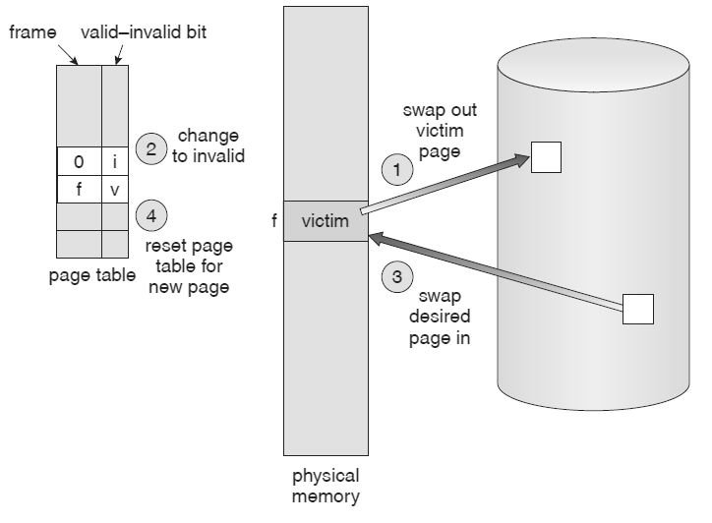

**Objective:**

The primary objective of this paper is to comprehensively analyze and compare different page replacement algorithms. Specifically, the study aims to:

1. Evaluate the performance characteristics of various page replacement strategies under different workload scenarios.
2. Assess the strengths and weaknesses of each algorithm in terms of factors such as page fault rate, system overhead, and adaptability.
3. Provide insights into the practical considerations and trade-offs involved in selecting a page replacement algorithm for specific computing environments.
4. Explore potential areas for optimization and improvement in existing page replacement techniques.

**Literature Review:** Numerous studies have been conducted to investigate the performance of page replacement algorithms in virtual memory systems. Early research focused on simple algorithms such as FIFO and LRU, examining their theoretical properties and practical implications. Subsequent work introduced more sophisticated algorithms and proposed optimizations to address the limitations of existing approaches. Comparative studies have been conducted to benchmark the performance of different algorithms using various metrics, including page fault rate, cache hit rate, and system overhead. Additionally, researchers have explored the impact of workload characteristics on the effectiveness of page replacement strategies, leading to the development of adaptive and hybrid approaches.

**Output:**

First In First Out:

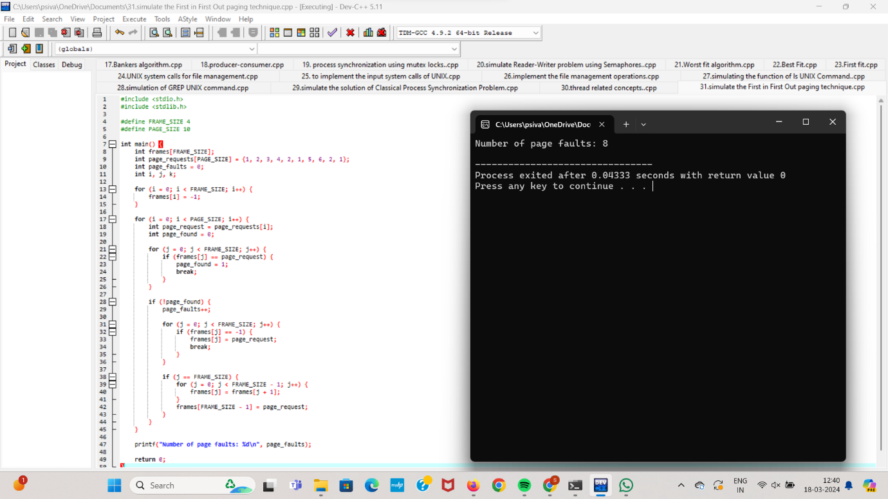

Least Recently Used:

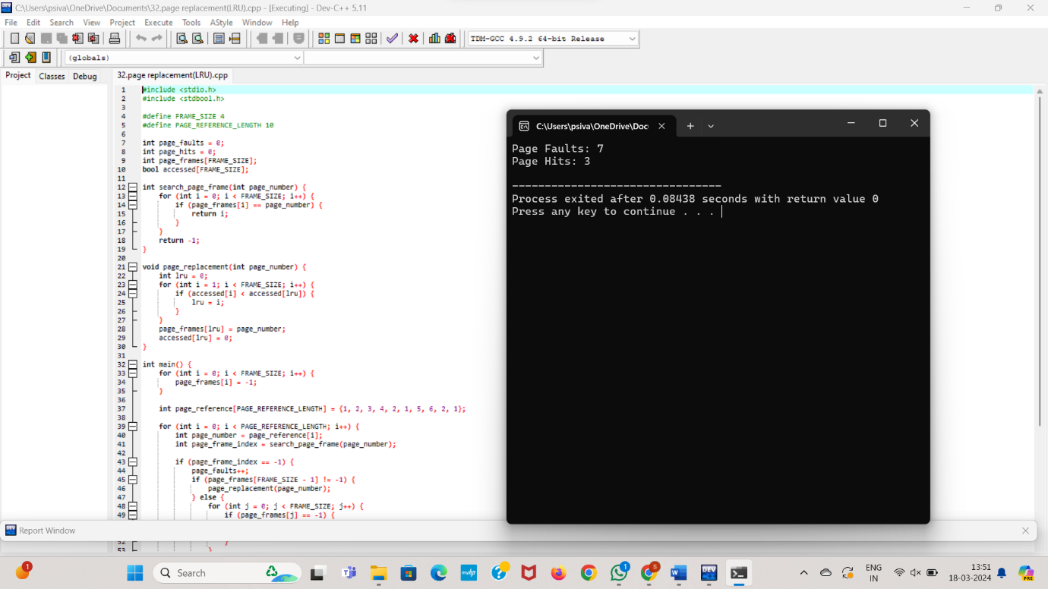

Optimal:

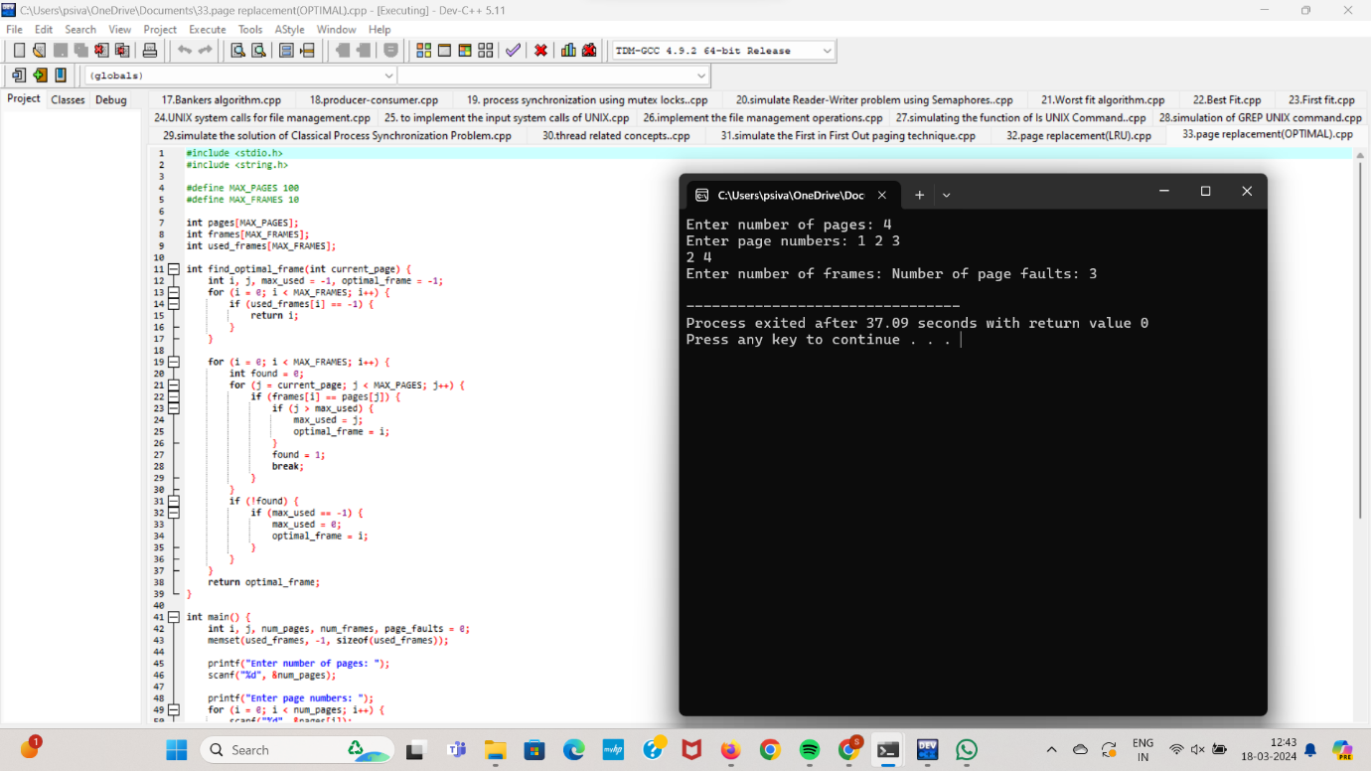

**Conclusions:**

In conclusion, page replacement algorithms play a crucial role in virtual memory management, influencing system performance and efficiency. This paper has provided a detailed examination of various page replacement strategies, including FIFO, LRU, Clock, and Optimal algorithms. Through comparative analysis and performance evaluation, we have highlighted the strengths and weaknesses of each algorithm under different workload scenarios. While no single algorithm is optimal for all situations, understanding the characteristics and trade-offs of each approach can assist system designers and developers in selecting the most suitable algorithm for a given computing environment. Future research may focus on developing adaptive algorithms that dynamically adjust their behavior based on workload characteristics, as well as exploring novel approaches to further improve memory management efficiency.

**References:**

1. Silberschatz, A., Galvin, P. B., & Gagne, G. (2018). Operating System Concepts (10th ed.). Wiley.
2. Tanenbaum, A. S., & Bos, H. (2014). Modern Operating Systems (4th ed.). Pearson.
3. Stallings, W. (2018). Operating Systems: Internals and Design Principles (9th ed.). Pearson.
4. Andrews, G. R. (2000). Concurrent Programming: Principles and Practice. Benjamin Cummings.
5. Denning, P. J. (1968). The Working Set Model for Program Behaviour Communications of the ACM, 11(5), 323-333.